DAC for MOSFET regulation

-Pros: Better voltage control for gate of MOSFET from Arduino.

Cons: Will have to include in list of materials

**From ChatGPT:**The **MCP4725 DAC** outputs a **DC (direct current) voltage**. This means the voltage output is stable and continuous, and it can vary smoothly within a set range (typically 0V to 5V or 0V to 3.3V, depending on the supply voltage).

### Using MCP4725 for Varying the Gate Voltage of a MOSFET:

1. **DC Output**:

- The MCP4725 produces a DC output voltage that can be varied digitally by sending different values through its I²C interface. For instance, you can smoothly control the output between 0V and the reference voltage (e.g., 5V).

2. **MOSFET Gate Control**:

- The gate of a MOSFET is typically controlled by a DC voltage, as MOSFETs are voltage-controlled devices.

- **For an N-channel MOSFET**: Increasing the gate voltage (relative to the source) turns the MOSFET on.

- **For a P-channel MOSFET**: Reducing the gate voltage (relative to the source) turns it on.

- Since MOSFETs require a **DC voltage** to operate properly, the MCP4725's DC output is perfectly suited for controlling the gate voltage.

3. **No AC Issues**:

- The fact that the MCP4725 outputs DC is not a problem—it's actually beneficial. For controlling a MOSFET, you want to apply a stable DC voltage to the gate.

- **AC signals** are typically used for switching or modulation in different applications but are not ideal for directly controlling the gate of a MOSFET in most cases where stable on/off states or precise control of conduction is required.

### Considerations:

- **Voltage Range**: Ensure that the voltage range of the MCP4725 (e.g., 0V to 5V) is appropriate for the MOSFET you're using. The gate threshold voltage (Vgs(th)) of the MOSFET should be within this range for the device to fully turn on or off as needed.

- **Drive Capability**: The MCP4725 has a limited current output (~25mA max). If the MOSFET has a large gate capacitance and requires a high gate charging current, you may need to buffer the DAC output using a gate driver circuit.

### Conclusion:

The MCP4725 is a good option for varying the **DC gate voltage** of a MOSFET. There should be no problem using it for this purpose, as long as the output voltage range matches the requirements of the MOSFET.

Sample Youtube video:

<https://www.youtube.com/watch?v=SgPbzAWIwlk>

**MOSFET Considerations:**

**Chat GPT:**  
Given the input voltage range of 12V to 20V and the battery being 12V, you will need a MOSFET that can handle voltages above the input range, with a suitable margin for protection and efficiency. Here are the key criteria and recommendations:

### Key Criteria for MOSFET Selection:

1. **Voltage Rating (Vds)**: Choose a MOSFET with a voltage rating of at least **30V** or higher to handle voltage spikes and provide a margin above your maximum input of 20V.

2. **Current Rating (Ids)**: Ensure the MOSFET can handle the current flowing through each source. For solar, hydro, and DC sources, this will depend on the power output. A typical value for low- to medium-power applications might be **10A or higher**.

3. **Gate Threshold Voltage (Vgs)**: Select a MOSFET with a **low gate threshold voltage** (Vgs(th)) that can fully switch on with Arduino logic levels (3.3V or 5V). Look for MOSFETs with a Vgs(th) of **1V to 2V** to ensure proper switching.

4. **Low Rds(on)**: Ensure the MOSFET has a low on-state resistance to minimize power loss during operation. A typical value would be **less than 100 milliohms**.

### Recommended MOSFETs:

1. **IRLZ44N**:

- **Vds**: 55V

- **Ids**: 47A

- **Vgs(th)**: 1-2V (works well with Arduino)

- **Rds(on)**: 0.022 ohms

2. **AO3400A** (for lower current applications):

- **Vds**: 30V

- **Ids**: 5.8A

- **Vgs(th)**: 1V

- **Rds(on)**: 0.047 ohms

3. **STP55NF06**:

- **Vds**: 60V

- **Ids**: 50A

- **Vgs(th)**: 1-2V

- **Rds(on)**: 0.02 ohms

4. **FQP30N06L**:

- **Vds**: 60V

- **Ids**: 30A

- **Vgs(th)**: 1-2V

- **Rds(on)**: 0.035 ohms

### How to Use:

- Connect the **drain** of each MOSFET to each power source (solar, hydro, DC).

- Use the Arduino to control the **gate** voltage (Vgs), determining which source is active based on your fuzzy logic algorithm.

- Connect the **source** of each MOSFET to the **input** of your battery charging circuit (e.g., LM2596 buck converter).

These MOSFETs should provide the necessary switching for your 12V battery charging system with inputs in the range of 12V to 20V.

**Pwede kayo pumili sa mga available dyaan sa taas. Pero Nakita ko lang yung STP55NF06L which might be a good power mosfet given na mataas yung rating ng max voltage and current nya, maybe beyond pa sa what is expected:**

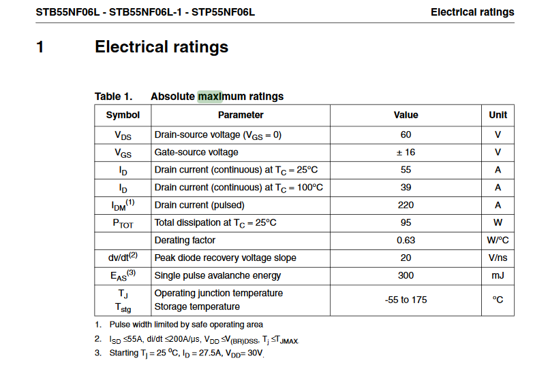

**Link of document:** [**https://www.st.com/resource/en/datasheet/stp55nf06l.pdf**](https://www.st.com/resource/en/datasheet/stp55nf06l.pdf)

**Shopee link:** [**https://shopee.ph/product/98591228/14809002186?gads_t_sig=VTJGc2RHVmtYMTlxTFVSVVRrdENkU1psNndicnpENjFrR2ZiZlcxU0ZETDZEOVhkV3NOQXMxR1g1WmNaOXd1UmxwOXE5TFJLYWZZWUI4bkIxTXVta0VNUzdGcUxnVGUzSjNRRk55S2ZVbVdFYmZJTlBNemtUUENyN1U4TG5FemY**](https://shopee.ph/product/98591228/14809002186?gads_t_sig=VTJGc2RHVmtYMTlxTFVSVVRrdENkU1psNndicnpENjFrR2ZiZlcxU0ZETDZEOVhkV3NOQXMxR1g1WmNaOXd1UmxwOXE5TFJLYWZZWUI4bkIxTXVta0VNUzdGcUxnVGUzSjNRRk55S2ZVbVdFYmZJTlBNemtUUENyN1U4TG5FemY)

**Consideration will be dapat di tataas yung current na dumadaloy sa input beyond sa Drain current, else magkakaproblema yung MOSFET.**

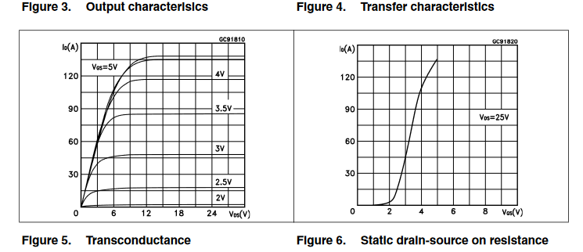

**Let me know what you think, pwede pa tayo pumili ng iba or maghanap if needed.**

**Pakibalitaan ako if may mga updates sa prof niyo.**

**We can also sched a meeting kung needed man. Thanks!**